**POLICY ON STUDENT DEPORTMENT AND DISCIPLINE**

1. **CODE OF DISCIPLINE**

Student discipline is one of major concerns and issues at the center of adolescents’ life in the school. Baringcucurong National High School implements a code of discipline that embodies standards of behavior benefitting mature and responsible adolescents.

The act of enrollment confirms the fact that the student and his parents agree to abide by the school policies, rules, and regulations on discipline.

All students should conduct and present themselves in a descent manner. They should follow the generally accepted norms of good behavior and at all times in all places should observe courtesy and decorum in dealing with other people.

1. **CAUSES FOR DISCIPLINARY ACTION**

The following acts or omissions are deemed improper conduct for which a student may be subject according to disciplinary actions, to wit:

**LIGHT OFFENSES:**

1. Non-submission of Letter of Excuse for absence/s or for tardiness.
2. Non-wearing/improper wearing of current school ID card with authorized ID lace and picture.
3. Lending and tampering of school ID.
4. Littering bottles, cans, pieces of paper and other disposable materials, eating or spitting in the classrooms, lobbies, corridors and other places in the school campus.
5. Chewing gum, lollipop ang using of momma within the campus or in the immediate vicinity of the school.
6. Loitering in corridors.
7. Name calling resulting to irritation or embarrassment and excessive teasing.
8. Eating inside the classroom during class hours.
9. Going out of the school campus without permit or out-slip signed by the class adviser.
10. Unauthorized posting, distributing or disseminating of announcements, posters, leaflets, opinionnaires, surveys, streamers or similar other materials in the school premises.
11. Disturbances like running, shouting, loud talking and laughing excessively along the corridors, obstruction or interference with the normal functioning of classes, school offices and recognized school activities.
12. Bringing pets or endangered species such as iguana, snakes, except when authorized.
13. Use of make-up and loud colored accessories, using hair dye, and sports-off heat styles such as “devil’s cut” under cut skin cut, etc.
14. Failure to return report cards/confirmation/return slips and other correspondence.
15. Wearing of earrings for men and wearing of more than 1 pair of earrings for female.
16. Use and charging of cellphones and other electronic gadgets inside the school premises.
17. Any other cause analogous to the foregoing as may be appropriated by the school.

Note: Light offenses shall be punishable with the penalty of:

1st offense – Oral reprimand or counselling

2nd offense – Censure/written warning

3rd offense – Suspension with community/school service (3 days)

**MAJOR OFFENSES:**

1. Frequent tardiness and five (5) consecutive absences
2. Truancy – six (6) accumulated absences.
3. Cutting classes (missing 1 or 2 classes without permission though the student is in the school premises).
4. Smoking, using of momma especially in such places; classrooms, library, halls, canteen, corridors, and other restricted areas within the campus.
5. Bringing in or imbibing or dispensing liquor or any intoxicating beverages, drunkenness or entering the school premises in state of intoxication.
6. Vandalism which is willful destruction of school property and which also includes but is not limited to, such as tearing off or defacing any library book or magazine, writing, drawing, sticking on or posting any materials on the walls, tables and chairs and on all other piece of furniture, breaking glass windows, show cases, door, laboratory equipment materials, or any electrical, mechanical and electronic gadgets or devices like television, portable speaker etc., removing or erasing or tampering with official notices, announcements and posters from the bulletin boards, destroying or tampering with any school property or committing similar acts.
7. Cheating. A student caught cheating in any examination, test, quiz project, report or assignment gets a failing grade in the said examination, test, quiz, project, report or assignment. However, if the student is caught cheating during the final examinations or in the submission of a major project, report or assignment in partial fulfillment of the requirements for a subject, he shall automatically get a failing grade for the subject.

For this purpose, “cheating” shall constitute, but not limited to the following acts:

* 1. Changing test questionnaires/answers;
  2. Communicating answers to another during a test through signs and notes electronically or otherwise;
  3. Exchanging answer sheets while taking test;
  4. Copying the answers from another students’ test papers;
  5. Allowing another student to copy from one’s test paper;
  6. Possession of notes (codigo) or crib books; or materials expressly prohibited during examination or test;
  7. Talking, standing, or transferring seats while inside the testing room without the authority/consent of the examination proctor;
  8. Plagiarism in projects, reports or term paper submissions or passing off as one’s own work somebody else’s work with or without major or minor adjustment. In-text citation should cite the (author, year, etc.)
  9. Not citing sources quoted materials even if these are just from the internet. The internet site and the date retrieved, etc. should be cited;

1. Organizing, joining, recruiting members for any fraternity/sorority unauthorized by the school, or any subversive organization in or outside the school.
2. Bringing, possessing, exhibiting and/or displaying obscene or pornographic magazine, pictures, videos or DVD’s or the like, within the school premises.
3. Abusive use of school facilities, space, building, apparatus, equipment, books, tools, materials, etc.
4. Public display of affection (PDA) inside and outside the school premises during school hours and activities.
5. Any other cause analogous to the foregoing as may be appropriated by the school.

*Note: Major/serious offenses shall be punishable with:*

1st offense – Written warning/censure to suspension with

Replacement/payment when applicable.

2nd offense – Suspension with community/school service (3 days)

3rd offense - Suspension with intervention (5 days)

GRAVE OFFENSES:

1. Theft, pilferage of school equipment, materials or supplies, extortion, robbery or an attempt thereof and any form of dishonesty.
2. Gambling in any form within the school premises.
3. Carrying unauthorized deadly/harmful weapons or explosives within the school premises, such as but not limited to guns, knives, icepicks, darts and the like.
4. Direct assault upon administrators, teachers, employees and students as well as uttering defamatory or libelous statements against them; participating in any melee or conflict, such as but not limited to brawls, fighting, stabbing, quarreling and other similar acts that injure, degrade or tend to injure or disgrace any fellow student or person in the school.
5. Tampering or forging, alteration, falsification or misuse of school records, documents and/or credentials and using them, knowing them to be tampered or forged, publishing false information about the school, its officials, faculty members, personal and students.
6. Giving or submitting fake, fabricated or misleading information on any official record or documents submitted to the school administration.
7. Hazing in any form, committed in connection with a student activity, whether within or outside the school premises. Due to serious injuries to health and even death of victims of hazing, the following penalty/action may be adopted upon the gravity of the case:
8. Recruiters who undertake the hazing may be dismissed/dropped from the school immediately.
9. Victims of hazing (whether voluntary or not) may be allowed to finish the school year and be given transfer at the end of the school year.
10. The use, possession, sale or distribution of narcotics or dangerous drugs, such as “shabu, marijuana or lysergic acid (LSD) except when expressly permitted by law.
11. Stealing/theft or damage to school property owned by any member of the school community, mulcting, extortion and making unauthorized collection or solicitation of money and property from any member of the school community.
12. Engaging in lewd, indecent, immoral or provocative conduct such as passionate kissing, necking, petting and similar acts while within the school premises or during school functions or activities.
13. Discourtesy to school officials, faculty members and nonacademic employees.
14. Unauthorized use of the school or school officials’ name for any purpose such as to solicit for donation.
15. Cyber bullying resulting to harassment, intimidation or humiliation through electronic means or other technology, such as, but not limited to texting, email, instant messaging, chatting, internet, social networking websites or other platforms or formats.
16. Other acts of abuse by a student, student or learner- refers to serious acts of abuse upon other student of the same school, not falling under the definition of bullying but not limited to acts of physical, sexual or psychological nature. (See Child Protection Policy, Deped Order No. 40, s., 2012)
17. Any other cause analogous to the foregoing as may be appropriated by the school.

Note: Grave offenses shall be punishable with:

1st offense – Suspension with intervention (5days)

2nd offense – Exclusion and recommendation for expulsion to the

Deped.

1. **DUE PROCESS**

Once a student is found to have committed a school violation, the following standards shall be complied with to protect the students’ right to due process:

1. The student shall be informed in writing of the nature and cause of any accusation against him/her/them.
2. They shall have the right to answer the charges against them, with the assistance of a counsel, if desired.
3. They shall be informedthe of the evidence against them.
4. They shall have the right to adduce evidence in their own behalf; and
5. The evidence must be considered by the investigating committee or official designated by the school authorities to hear and decide the case.

**PROCEDURES:**

**For light offenses;**

1. Subject teacher shall conduct a preliminary investigation. Action should be taken at his/her own level.
2. The teacher classifies the concerns into academic, behavioral or disciplinary*. If academic refer to the school head, if behavioral, refer to the class adviser, and if disciplinary, refer to the discipline officer. The issue must be settled at this level.*

**For Major and Grave offenses;**

1. Refer to number 1.1 and 1.2 above guidelines.
2. Call the attention of the parents.
3. The school head shall conduct a separate investigation of the case and thereafter makes necessary referral to the disciplinary board chaired by the discipline officer to investigate the case and review. The board submits its findings and recommendations to the school head as grave offense and shall be subject to disciplinary action.

**ALL PARTIES CONCERNED SHALL BE ACCORDED DUE PROCESS**

1. **CATEGORIES FOR ADMINISTRATIVE PENALTIES**
2. COUNSELLING

* A notice to the student that continuation and/or repetition of specified behavior or conduct may lead to other disciplinary action.

1. REPRIMAND

* Oral or written warning for violation of specified rules and or regulations.

1. SUSPENSION

* The penalty in which the school is allowed to deny or deprive an erring student of attendance in classes for a period not exceeding twenty percent (20%) of the prescribed class days for the school year. The decision of the school in every case involving the penalty of suspension, which exceeds twenty percent (20%) or the prescribed school days for a school year, shall be forwarded to the Deped Regional Office concerned within ten (10) days from the termination of the investigation of each case for its information.
  1. With intervention
  2. With community service

1. EXCLUSION OR DISMISSAL

* Is the penalty which the school is allowed to exclude or drop the name of the erring student from the school for being undesirable and transfer credentials be immediately issued. A summary of investigation shall have been conducted, and no prior approval of Deped is required in the imposition of the penalty of exclusion together with all the pertinent papers thereof, shall be filled in the school for a period of one year in order to afford the Deped opportunity to review the case in the event an appeal is taken by the party concerned.

1. EXPULSION

* Is an extreme penalty on an erring student consisting of his exclusion from admission to any public or private school in the Philippines and which requires the approval of the Secretary of Deped. The decision of the school on every case involving the penalty of expulsion together with the supporting papers shall be forwarded to the Deped Regional Office concerned within ten (10) days from the termination of the investigation of each case.

**CHILD PROTECTION POLICY COMMITTEE MEMBERS:**

Chairperson:

**LORETA J. LARANANG**

Teacher In Charge

Vice-Chairperson: **WILMA L. LOPEZ**

CPP Coordinator/LRPO

Teacher Representative:

**LOVELY JOYCE B. BALISONG**

Discipline Officer

Parent Representative:

**RIMANDO B. COLLADO**

SPTA President

Community Representative:

**SILVER MAR B. GALBOY**

Barangay Captain- Baringcucurong

Student Representative:

**RIANN JHAN C. COLLADO**

SSLG President

**LORETA J. LARANANG WILMA L. LOPEZ**

Teacher In Charge CPP Coordinator/LRPO

**LOVELY JOYCE B. BALISONG**

Discipline Officer

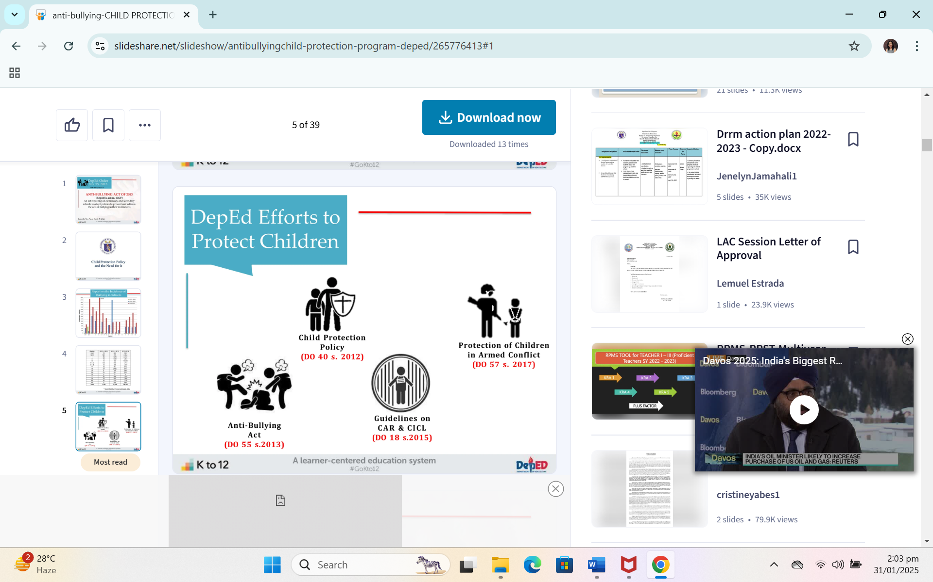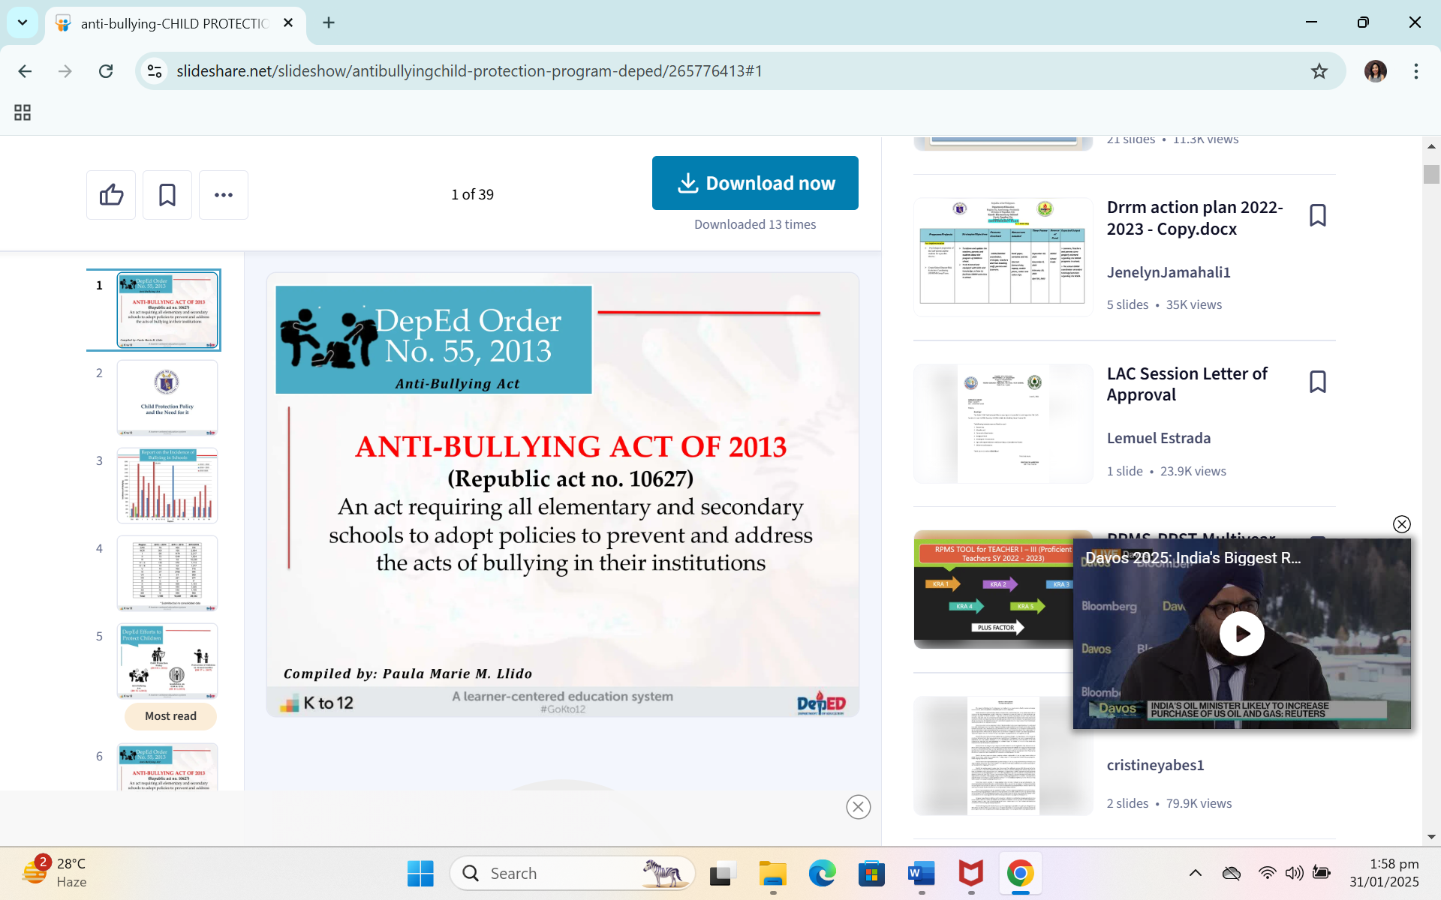

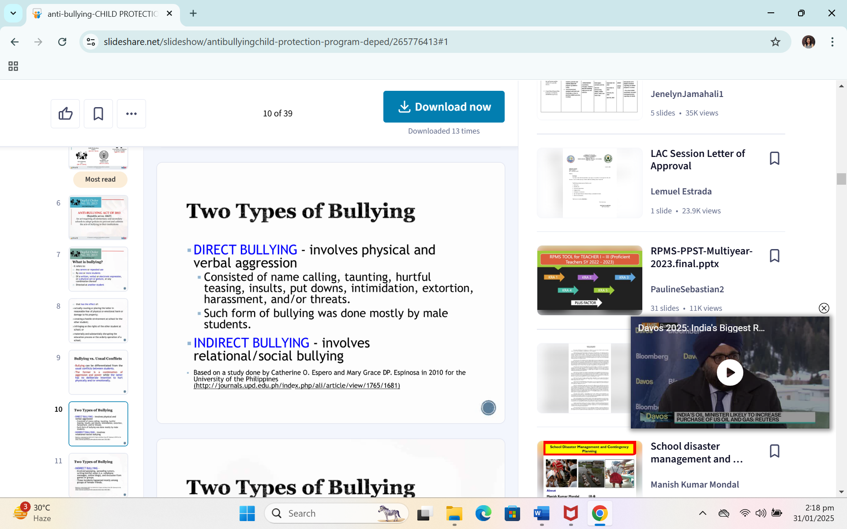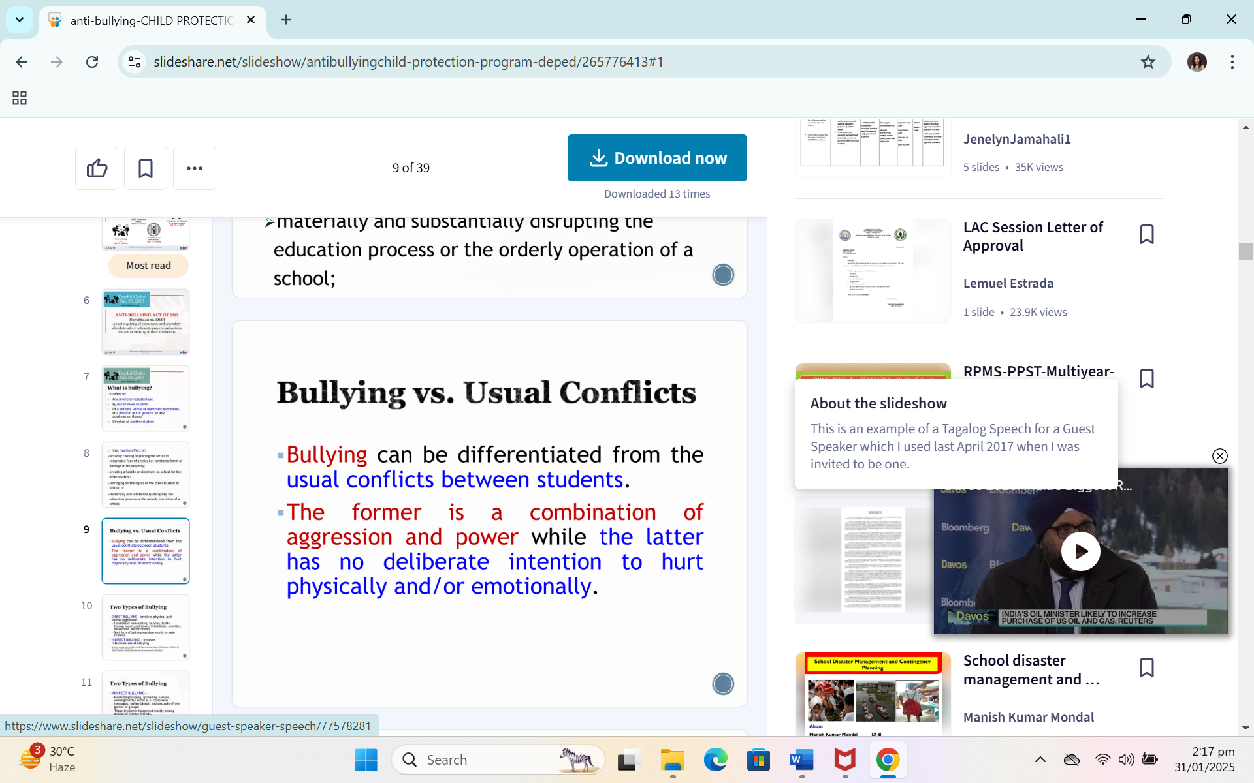

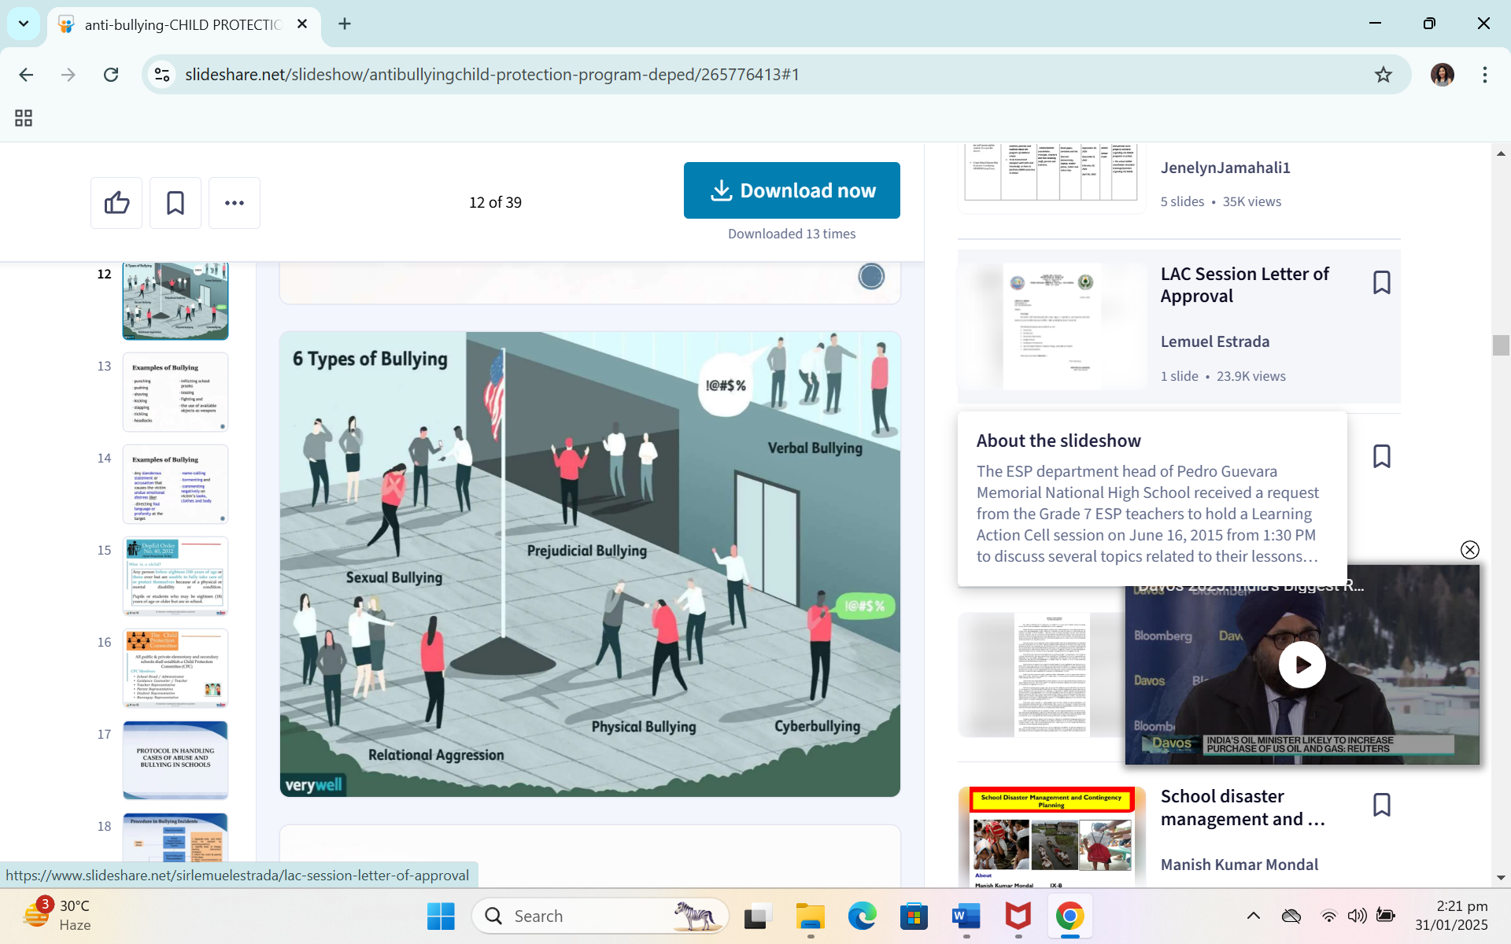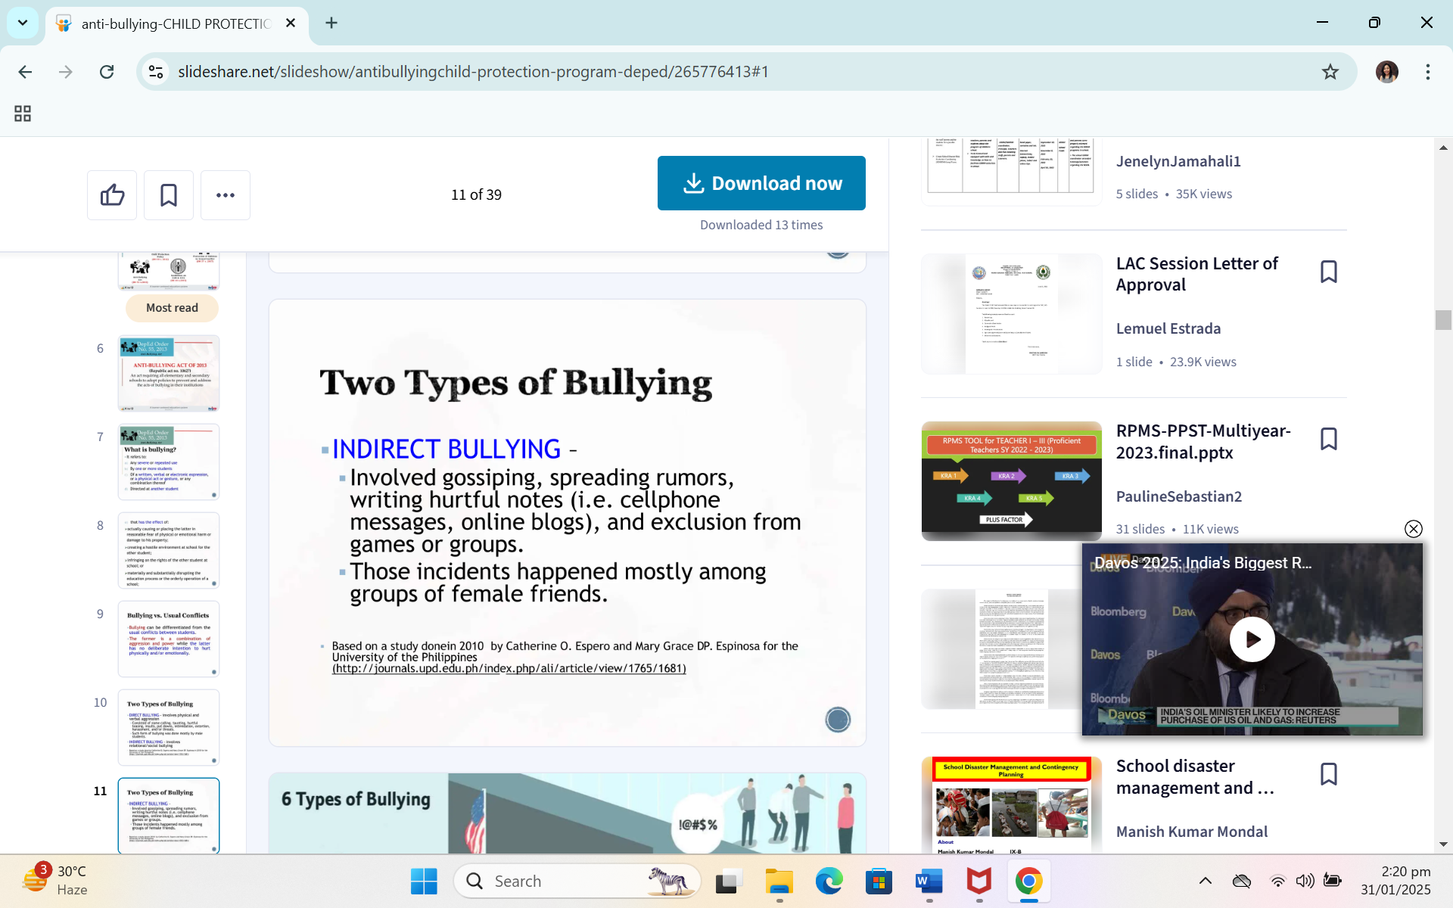

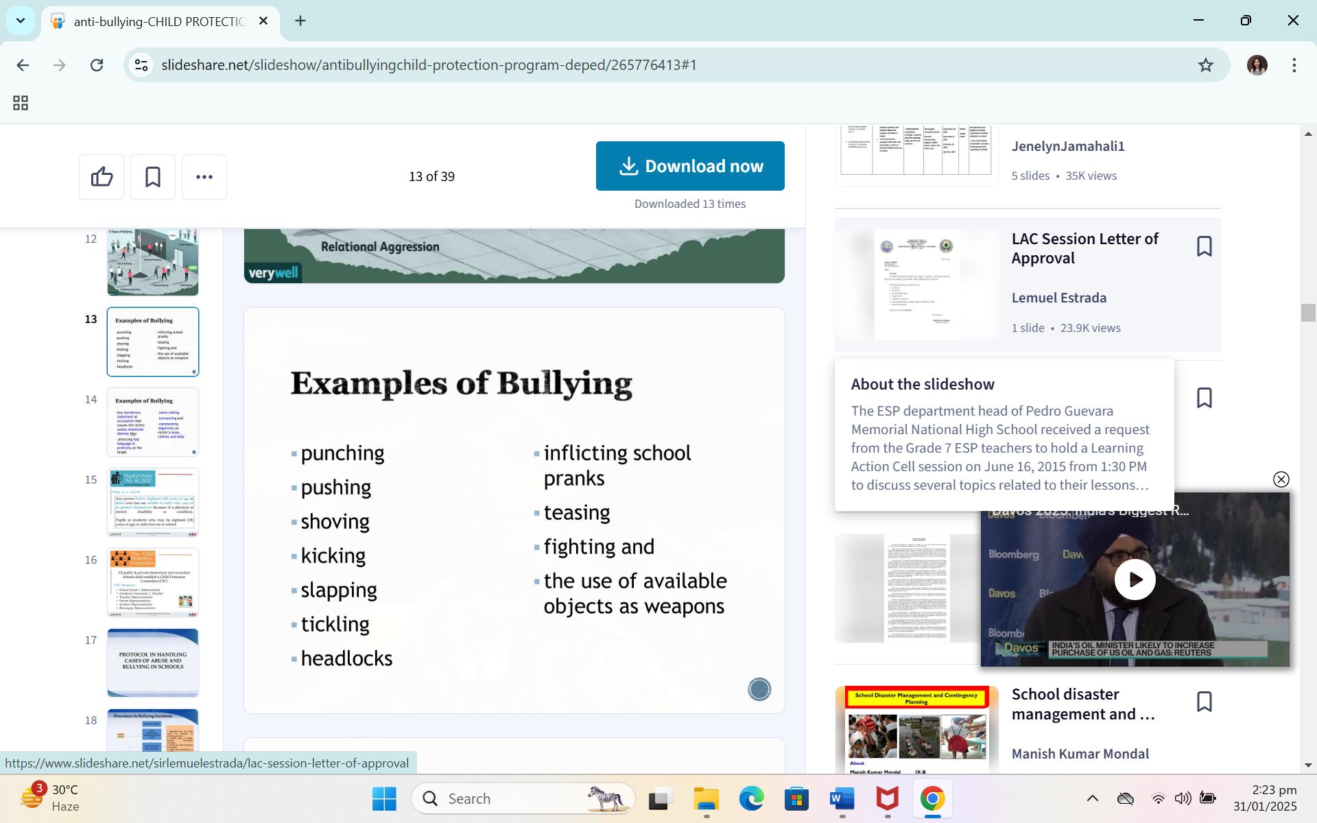

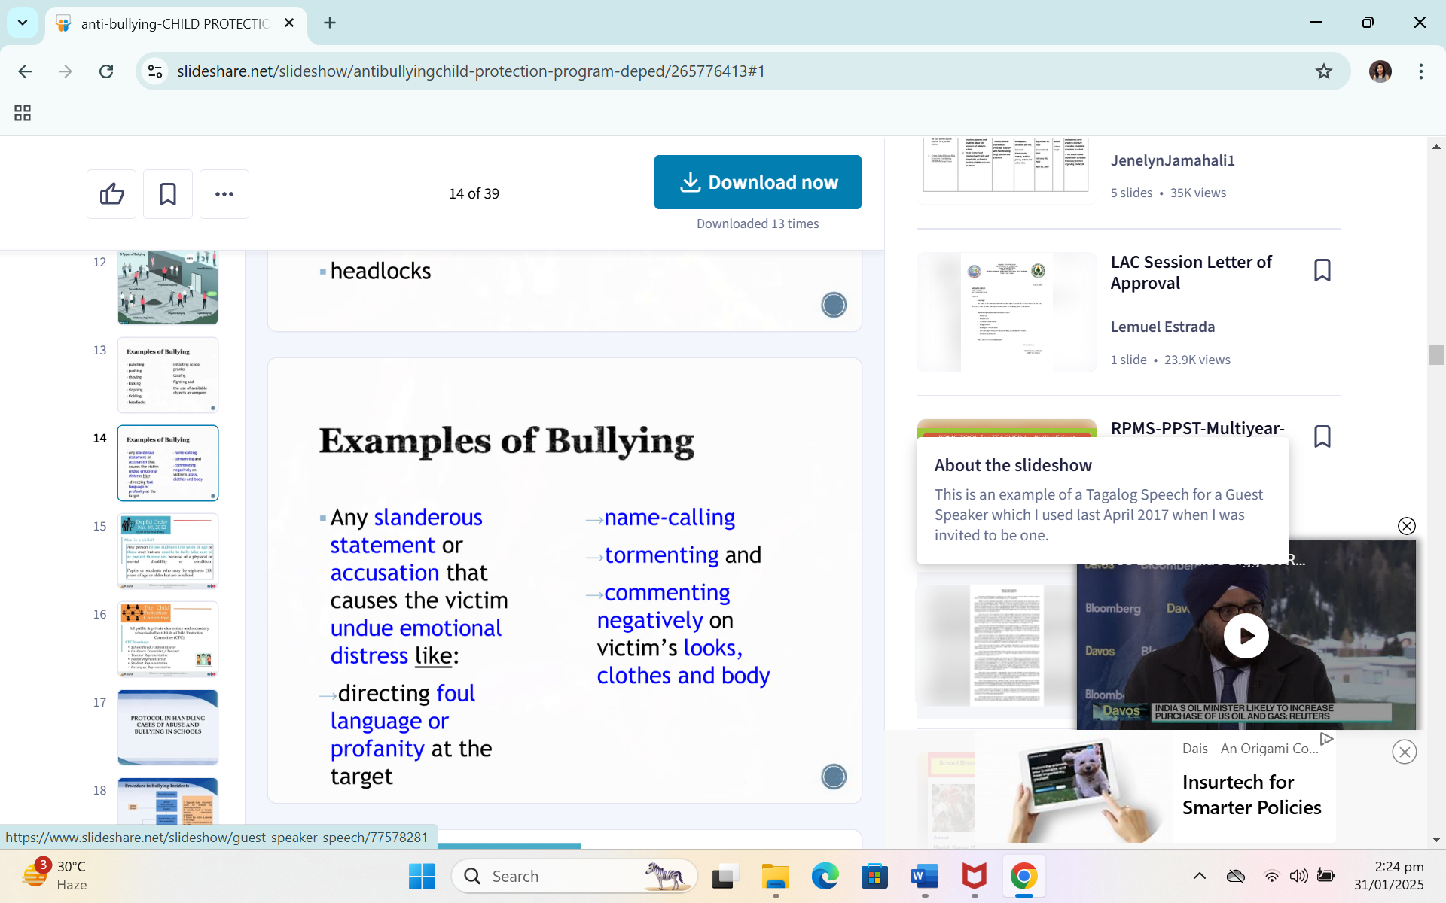

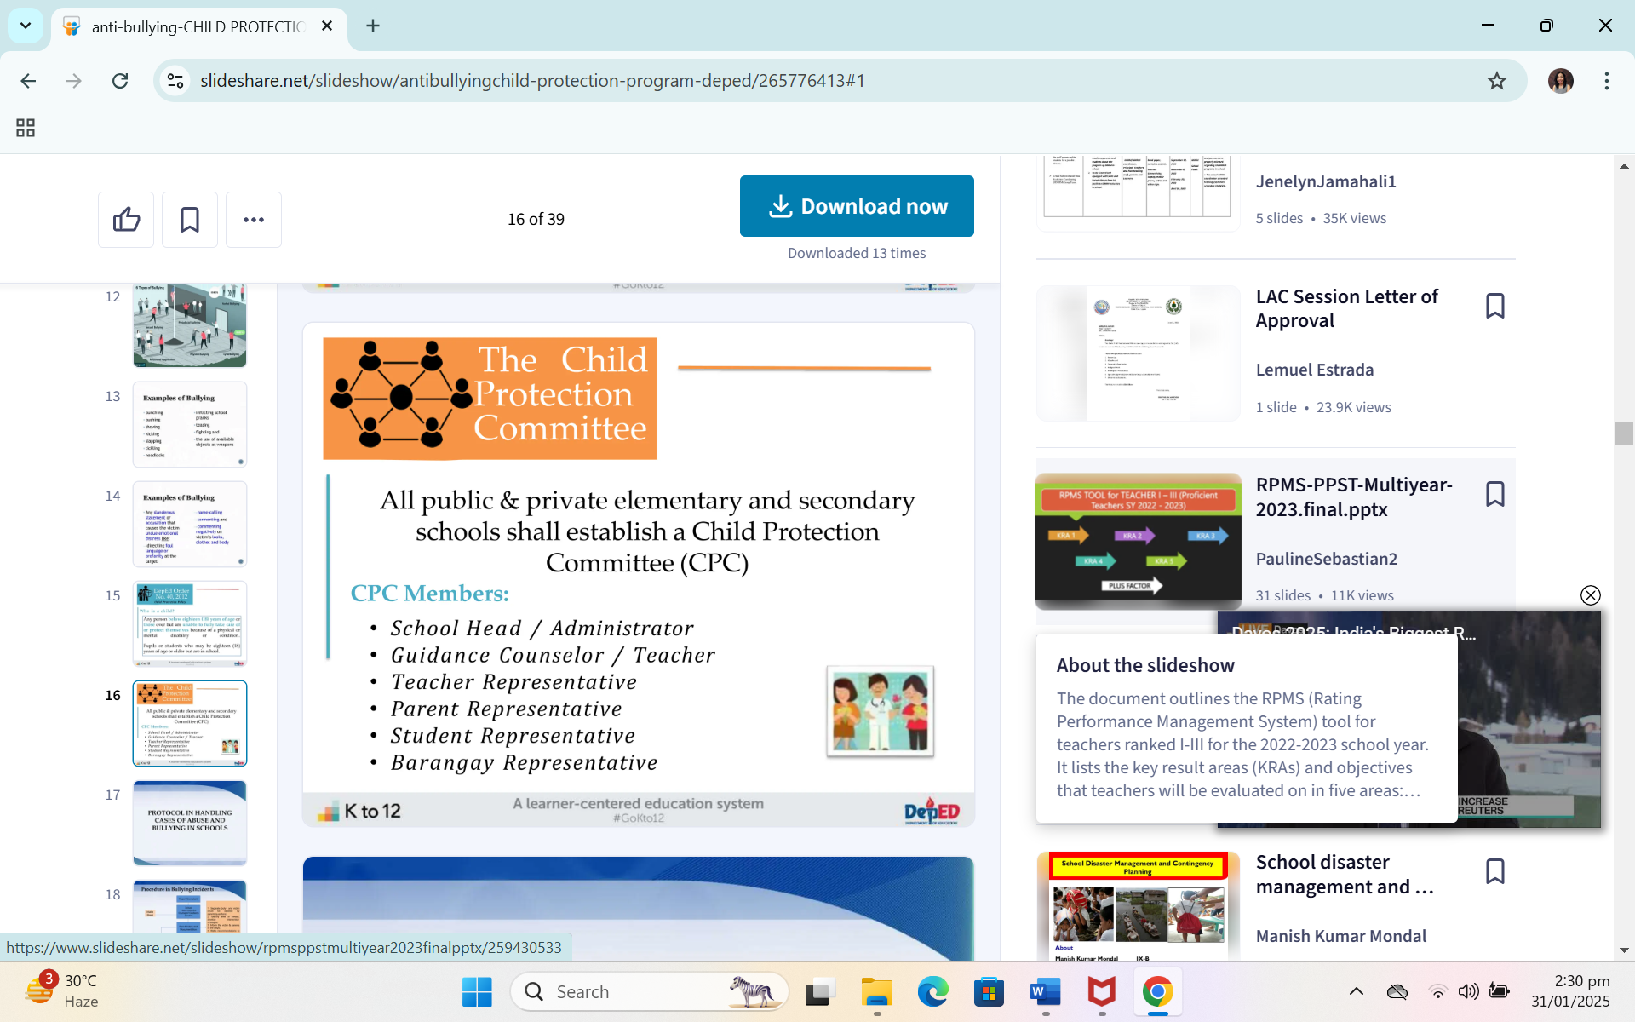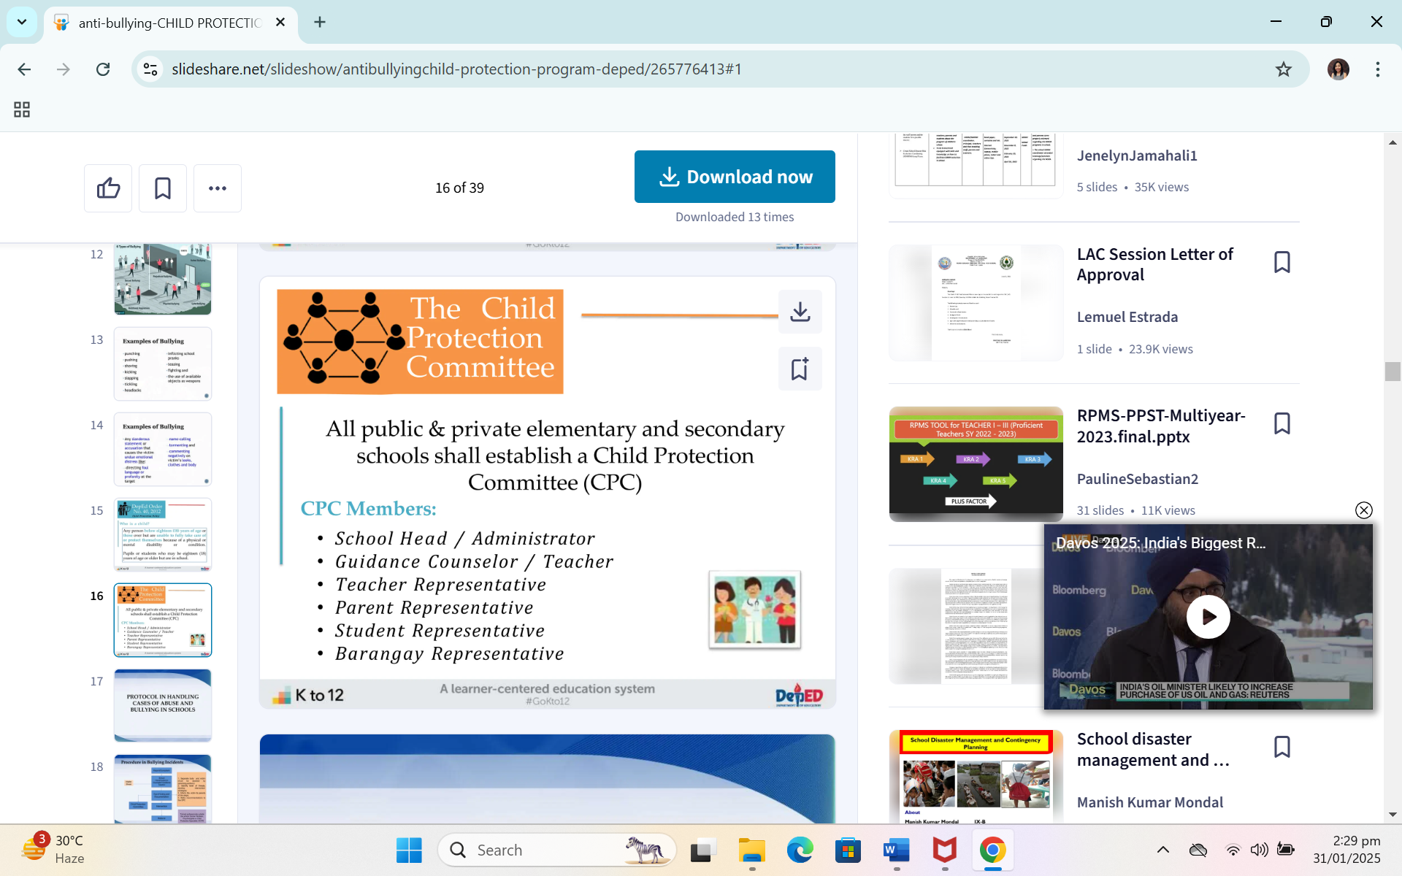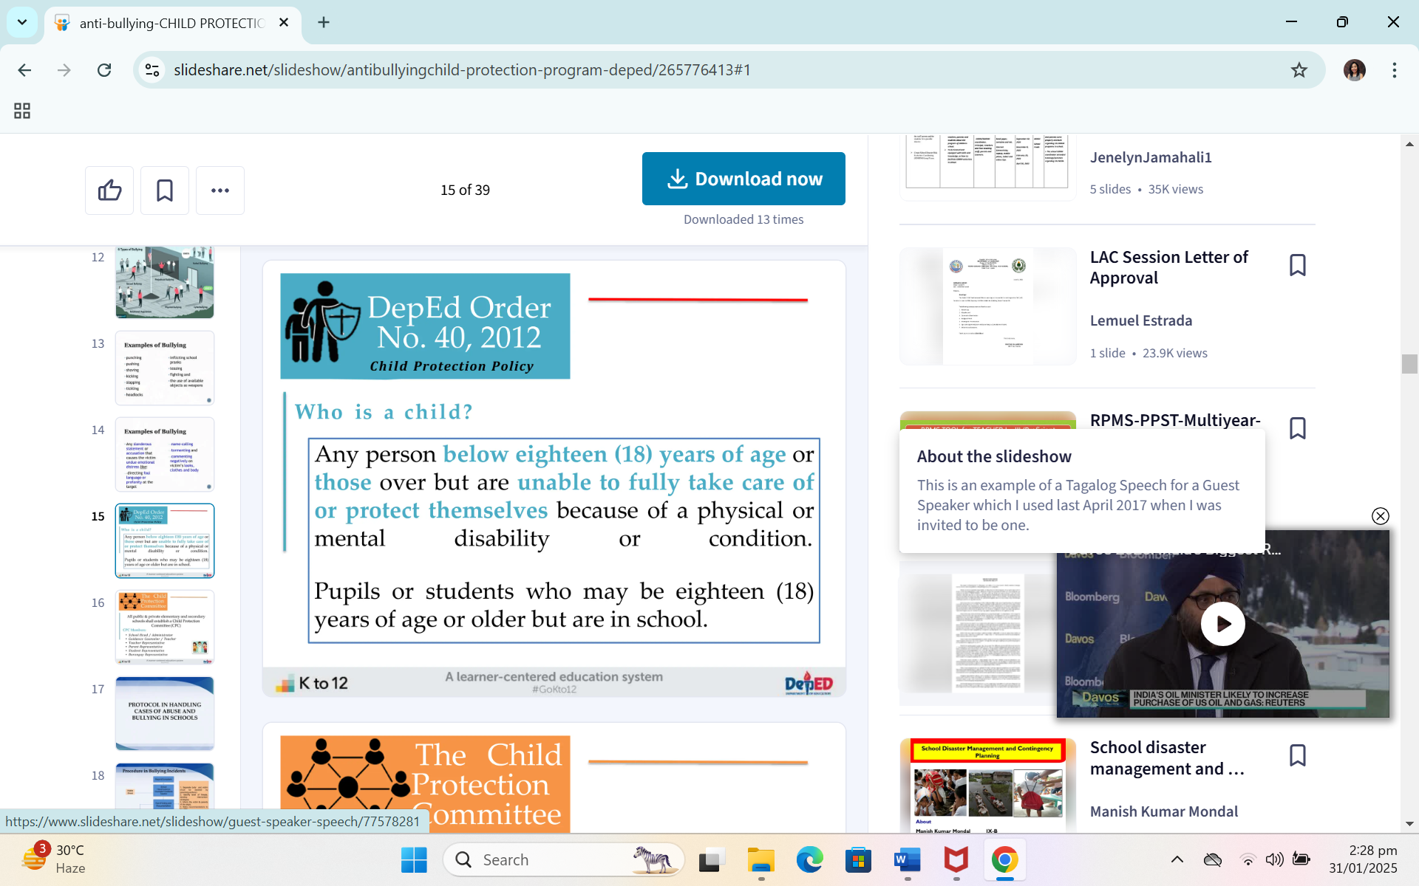V

